ConnectED

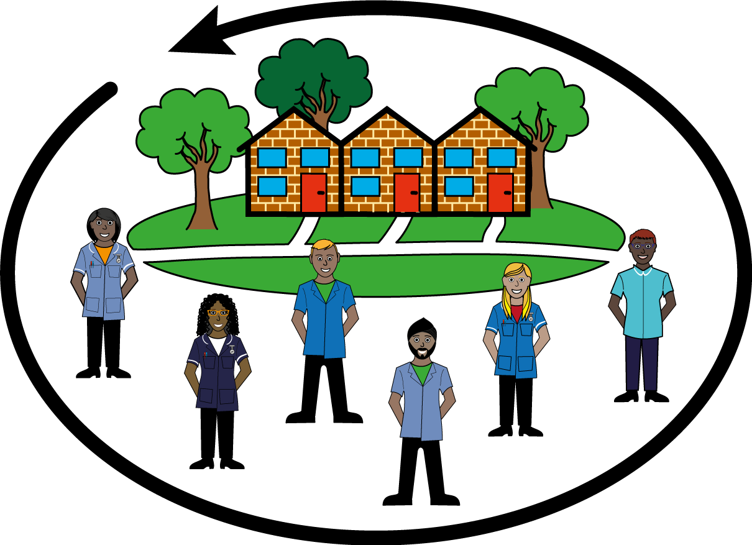 | Have you received a service from Adult Social Care?
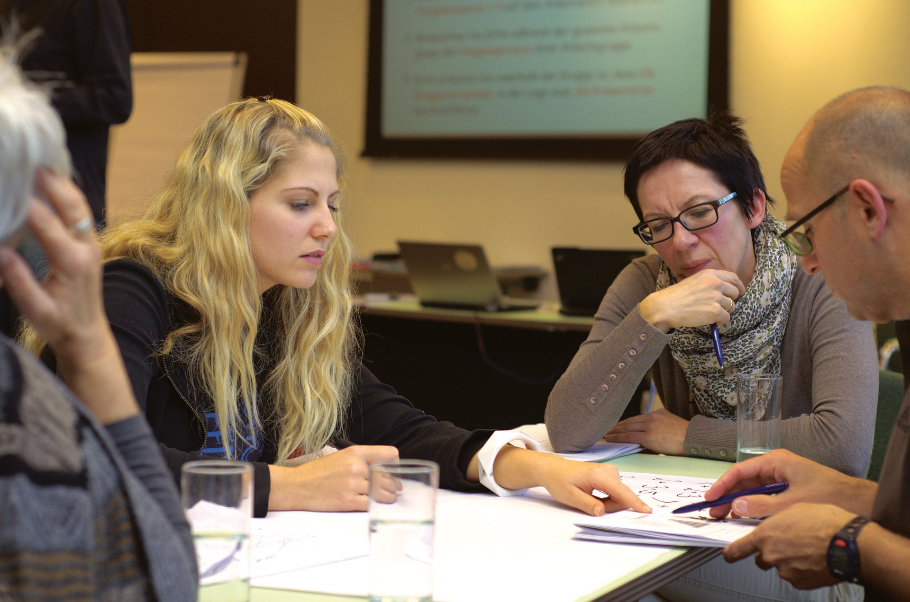 | Could you help decision makers make better decisions?
ConnectED | Then get involved in ConnectED
 | ConnectED is a research project about adult social care. It is led by the University of Bristol
 | We will have researchers in adult social care agencies
 | We also need people to join a Service User and Carer Advisory Group
 | And also people to join an Experts by Experience panel
 | You will take part in meetings to talk about the project
 | We will pay you for taking part
If you are interested, we would like to hear from you
jon.symonds@bristol.ac.uk

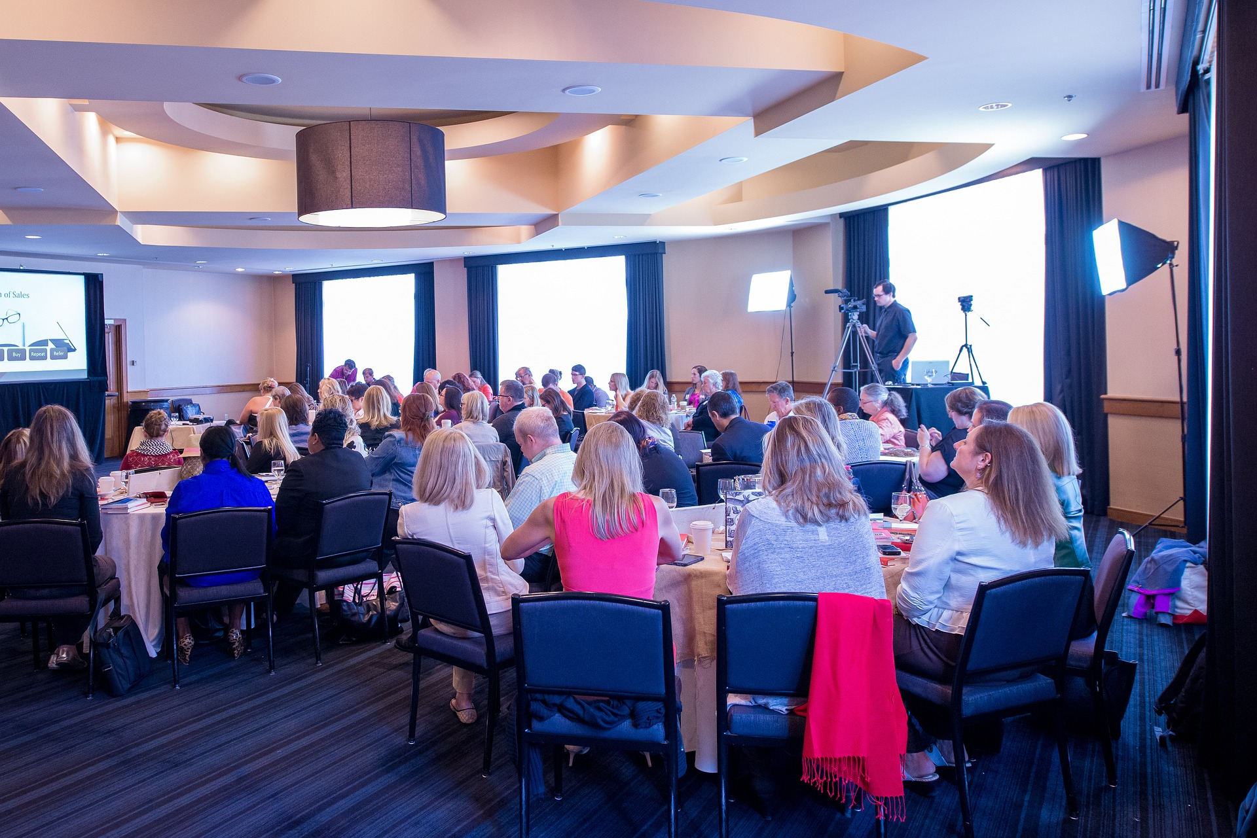 | Come to a meeting  On Zoom –  At the university -

